A1400 University Center
Tallahassee, Florida 32306-2370
Office: 850-644-6850 | Fax: 850-644-8921
http://procurement.fsu.edu

Notice of Cancellation

Pursuant to BOG 18.002, notice is hereby given that the below solicitation is cancelled effective
.

Cancellation Reason: The University has decided not to pursue this project at time.

A new solicitation will not be issued.

Solicitation Number: ITN 5750-1
Solicitation Title: Arena District Hotel & Convention Center
Address Cancellation inquiries to:

Name: Rosey Murton E-Mail Address: rmurton@fsu.edu

Any supplier/interested person who is disputing the cancellation or is adversely affected by a decision or intended decision concerning this competitive solicitation may file a protest in compliance with the Florida Board of Governors'(BOG) regulations. Failure to timely file a protest or failure to timely deliver the required bond or other security in accordance with the BOGs’ Regulations 18.002 and 18.003 shall constitute a waiver of protest proceedings.

Address Protests to:

Chief Procurement Officer A1400 University Center Tallahassee, FL 32306-2370

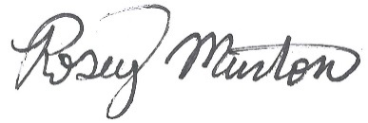
Posting Dates
From: 8/22/22 11:30am
To: 8/25/22 11:30am

Rosey Murton
Director & Chief Procurement Officer

