After you punchout
Please click on orders
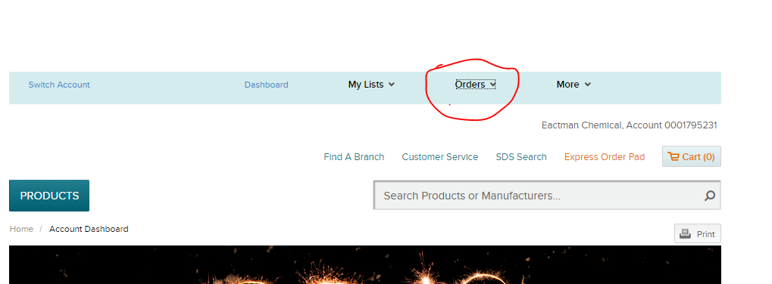

Then quotes from the drop down
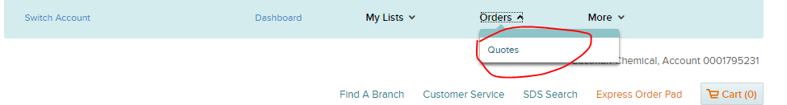

The quote will be found under the “My Quotes” section.
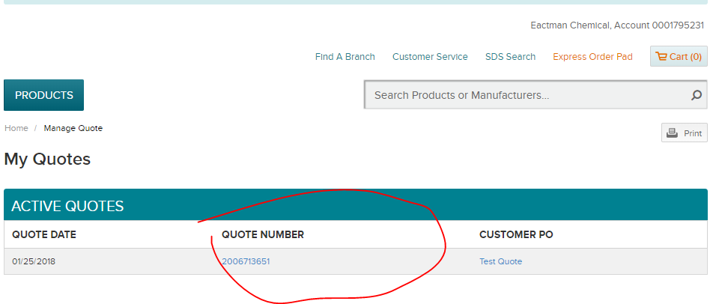

Once the quote number is clicked on it will bring up the quote where an order can be made.
You can click on select all and then the add to cart button to add all products to cart or individually add the items to cart as well.

