Solicitation Number: ITN 6471-6
Solicitation Title: Cyber Liability Insurance Broker Services

Meeting Agenda: Award Decision Meeting
Start Date/Time (EST): Friday, February 10, 2023, at 8:30 a.m.
Location: Via Zoom –
https://fsu.zoom.us/j/92129625135?from=addon
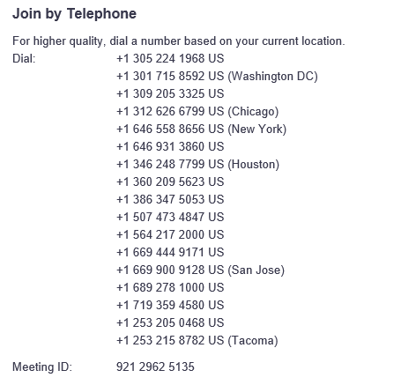
Agenda: Award decision by consensus of committee
A1400 University Center Tallahassee, Florida 32306-2370
Office: 850-644-6850
http://procurement.fsu.edu
Matters to be considered are those identified in the agenda for said meeting.
Accommodations can be provided for special needs by email to Natalie Mize at least 48 hours in advance.
Direct any questions to Natalie Mize in Procurement Services at nmize@fsu.edu.

