Contract Lifecycle Management (CLM) Job Aid (Contracts Module)
Purpose
To assist users with detailed and step-by-step directions when working in the CLM module, which is a part of the SpearMart system (Jaggaer). SpearMart is the system where the University’s sourcing, procurement, and contracting activities take place. This module is only accessed with assignment by the University’s Contract Administrator.

Resources
Contract Administrator
Office of Procurement Services
contracts@fsu.edu

Definitions:

Work Group – The Work Group is the Department or Office by which the roles are assigned. The Work Groups are set up in tiers, and users should select the most specific tier possible. For example, if the Contract Manager works in Facilities, they would select the Finance and Administration main tier, then the Facilities selection under the main tier.

Contract Type – The type of contract the Contract Manager will create, based on the goods/services in question. Contract Types assist in driving workflow in the system. Again, the user should select the lowest level tier selection possible to ensure the correct template and workflow is used.

Template – Templates are the contract boilerplate language that has been set up for each contract type to assist the Contract Manager in drafting. The language is pre-approved by Office of General Counsel and templates are created to assist with consistency in contract language as well as efficiency with contract approvals. If pre-approved templates are used, the review and approval process will be quicker.

First/Second Party – These are FSU and the vendor/provider in question. The system will default to FSU as the First Party in most scenarios, but this can be changed if we are the second party. The Second Party is typically the party in which FSU is going to do business with.

Workflow – The workflow is the process by which approvals and signatures are obtained. The workflow is driven by Contract Type, Work Group, and custom questions which appear in the “Create Contract” action. The module will automatically direct the contract to the appropriate approver based on how the contract is set up.

Module Roles:

Contract Manager – This user is the person(s) assigned to create/edit/manage contracts within a specified work group. One person should be assigned this role, with the option to add additional users as backup. Either the Contract Manager or the Contract Administrator roles may edit this user(s).

Contract Approver – This user may approve contracts in work flow, but may not create or edit contracts without also being assigned the Contract Manager role. The Contract Approver is similar to the approver role in the Requisitioning module of SpearMart.

Contract Stakeholder – This user may view contracts in their assigned work groups, but may not create or edit contracts.

Contract Administrator – This user is assigned all work groups and contract types and may create/edit any contract. Currently, this user is the University’s Contract Administrator and backup. This role is administrative in nature and will not edit or create contracts without communicating with respective Contract Managers.

Section A: Access, Login, and Contracts Home

- Login for this module is done through SpearMart, so login to SpearMart as you would normally. If you need to request access to the Contracts module, visit the SpearMart User Access Job Aid.

- Once you have logged into SpearMart, visit the “Contracts” tab on the left side of the screen.

- Verify that in ‘Contracts’, you see the following list of options if you are a Contract Manager, one of which should be ‘Create New Contract’. For Contract Stakeholders and Approvers, you will not be able to “Create New Contract” unless you also have the Contract Manager role.

- To maneuver to Contracts Home, select “Contracts Home” from the list.
- From here, you can see your Contract dashboards, alerts and search screens. You can search for contracts with a simple or advanced search, check on the status of your contracts (if you are a Contract Manager) and create contracts.
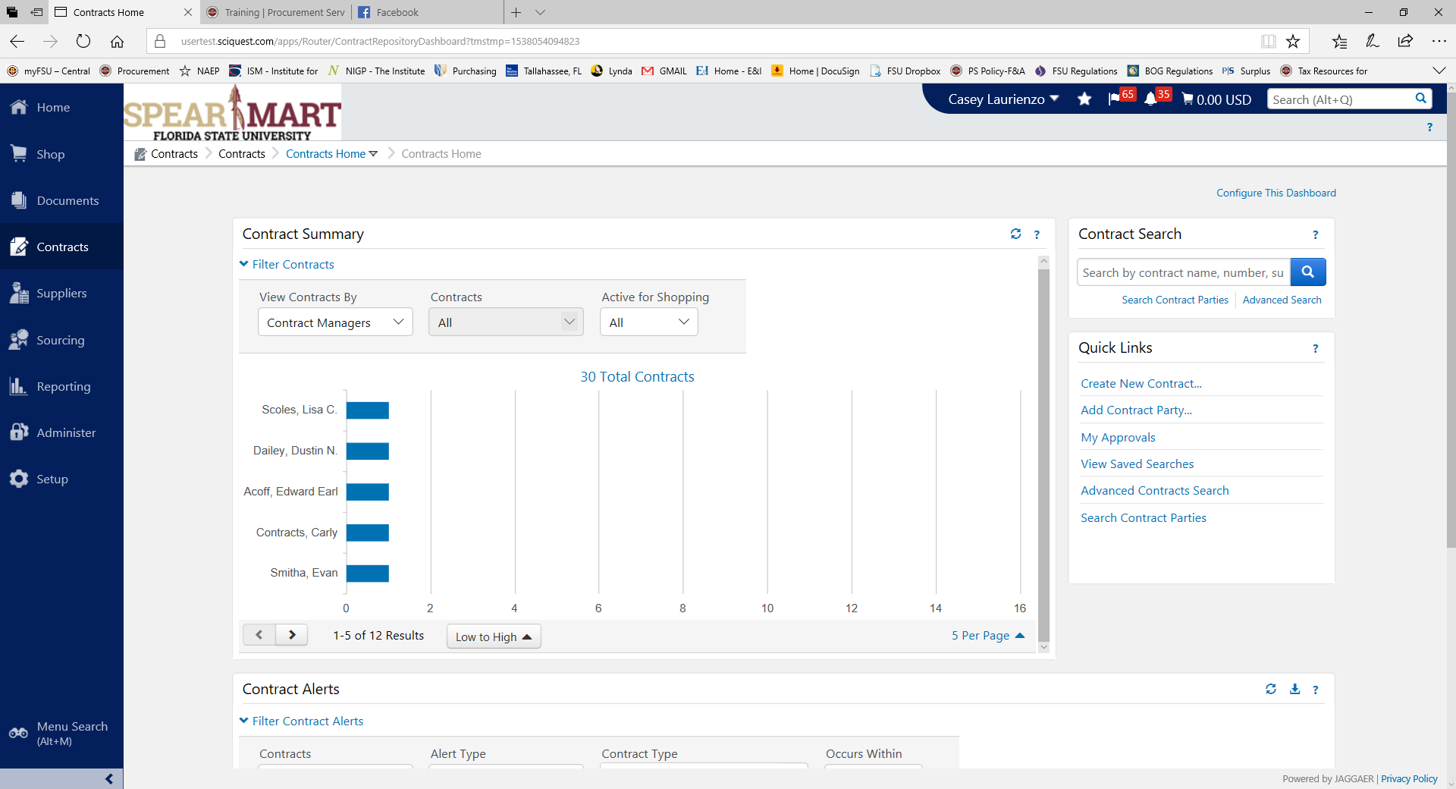
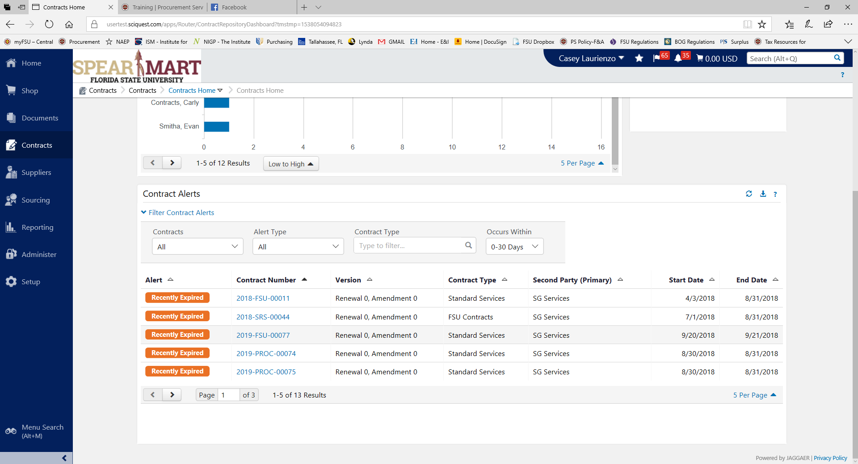

Section B: Create a Contract

- If you are ready to create a contract in the system, select ‘Create a Contract’. You can also select “Contracts Home” and then “Create a Contract” from the Contracts home page.

OR

- From the Create a Contract screen, you will be asked to enter the Contract Name and Contract Type. Remember: The Contract Name is not the contract number, which is assigned automatically by the system. The Contract Name should be informative but short, for example “TCM Testing Services”.
Next, select a Contract Type. If you don’t know the type, simply select the Magnifying glass and search options will appear. See Appendix A for Contract Type definitions.
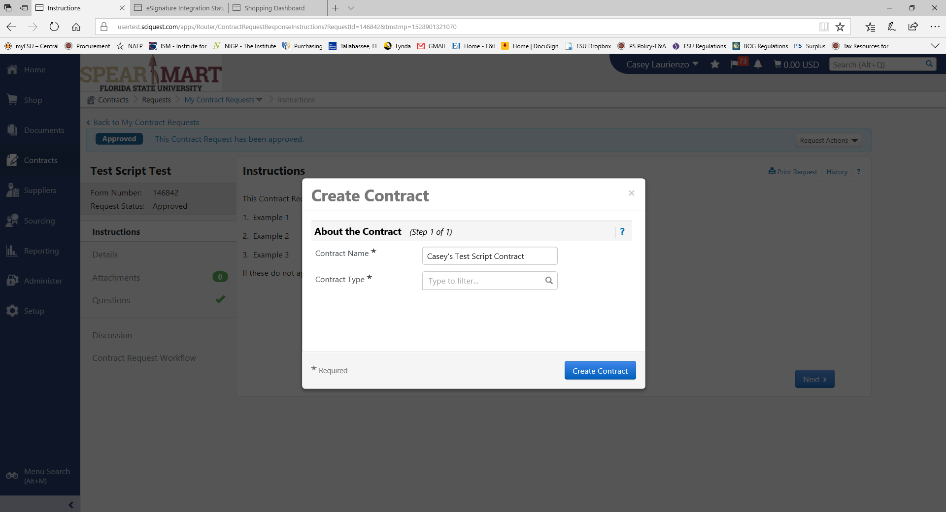
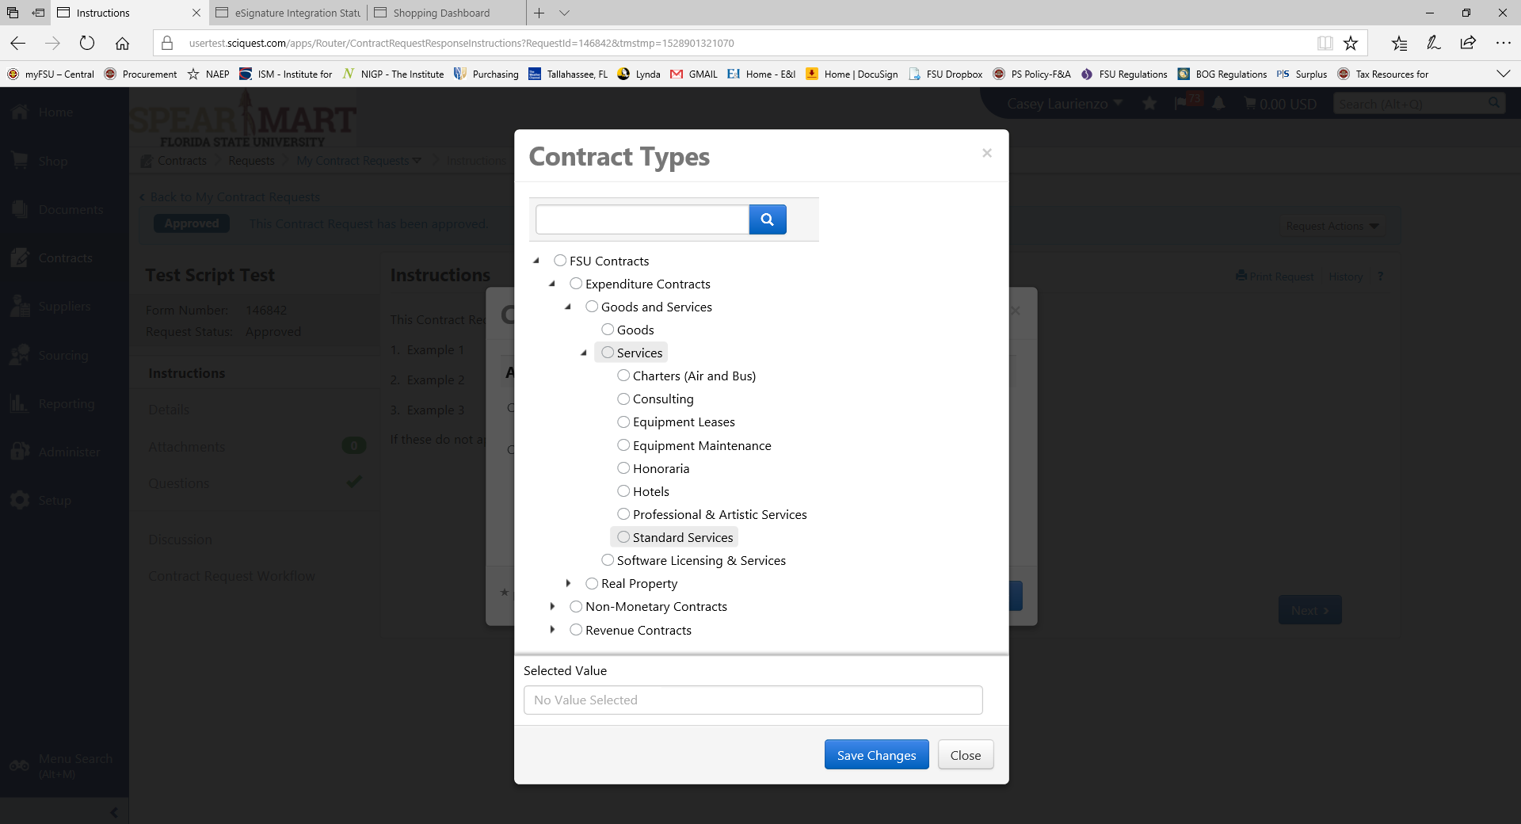

Please note the black arrows next to the Contract Type Names. These arrows indicate that this item can be filtered further. DO NOT USE the “FSU Contracts” contract type, as it is just a category name. Please filter as far down as possible to select an appropriate contract type.

- Once you’ve selected a contract type, then select a Work Group – pick the Work Group that you belong to and remember that you will need to filter down several sections to get to the most appropriate section. DO NOT select “FSU” as your workgroup, this is simply a category name. Filter down as far as you can go to select the appropriate section. “Save Changes”.

- For the Template, select the template from the choices tied to your Contract Type (there may only be one). It is critical if you are drafting a contract to select the appropriate contract type. Once completed, select “Save Changes” and you will see the Contract form appear. If you are not using a pre-approved FSU template, then simply leave blank (ex: we are signing the Second Party’s agreement, which was not authored by FSU).

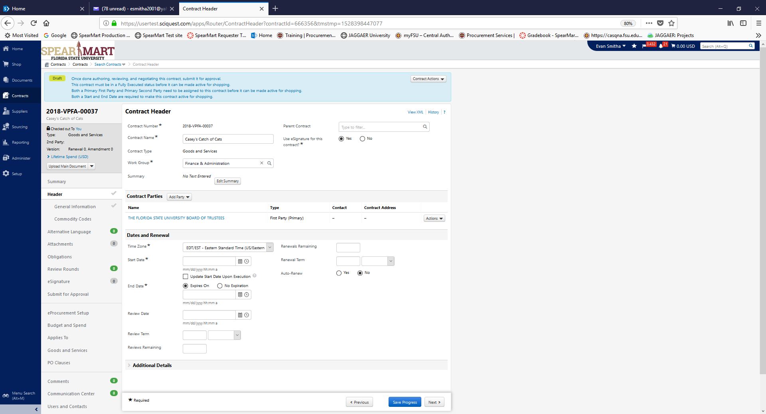

- This form has tabs on the left that you must work through and complete, one section at a time.
Let’s start with the Header Section:
- Fields you already created in the initial screens will appear, like Contract Name. However, please note that these fields are still editable while in “Draft” stage.
- The contract number was created by the system with the following methodology: {Fiscal Year}-{Work Group}-{Sequential Number} and cannot be edited.
- Contract Summary is optional but recommended.
- Parent Contract: You are able to link to a parent contract, as long as the contract is in the Contracts module. Simply search for the contract and select.
- Use eSignature: This field will default to “yes” and will link automatically to DocuSign for final signature. The University’s policy is to use DocuSign for signatures where possible; however, in the rare scenario where “wet signatures” are needed, simply select “No”. If you are planning to use the “no” option for eSignature, please contact the Contract Administrator first, to ensure there are no delays.

- Contract Parties Section: The first party will always default to FSU. Even if we are uploading and signing another party’s agreement, we will still be the First Party for the sake of the module. At this point you will also want to populate the Second Party, which would be the vendor. Select the ‘Add Party’ button and choose ‘Second Party’. If your Second Party is not in SpearMart already, you will need to add them by following the normal add supplier process found on the Procurement Services website: https://procurement.fsu.edu/suppliers. Vendors MUST be a registered SpearMart vendor in order for the contract to be executed!

- Dates and Renewal Section:
- Time Zone: This should default to Eastern, if not, simply change.
- Start Date: Required, cannot be a past date, can be a future date. If you want the start date to be the contract signature execution date, then select the checkbox under Start Date and add an estimated Start Date. The system will automatically update with the last signature in DocuSign OR the upload date if you aren’t using DocuSign.
- End Date: Required, must be a future date. Although the option of “No Expiration” exists in the system, please remember that generally we do not execute documents with no end date, per University regulations and Florida Statute. If you think you will need to use this option, contact the Contract Administrator first!
- Review Info: Not required, use if you want notifications for business reviews (contract management function).
- Renewal Info: If you contract contains renewals then these fields are REQUIRED. NOTE: If the contract contains renewal options, please enter, if not the contract will not be able to be renewed!
This is the last section on this tab, so remember to Save Progress on the bottom of your screen! Move to Next after you Save Progress.

- General Information: This section is comprised of custom questions that will help build the contract template but also to help drive workflow. Different questions will appear for different contract types, so please ensure you’ve selected the right type. Once completed select “Save Progress” and “Next”.
- Contract Value vs. Original Contract Value: If the contract is an original, not a renewal, then only enter a Contract Value. If the document is a renewal, please ensure that you enter both the Original Contract Value and then the Cumulative total value in the Contract Value field.
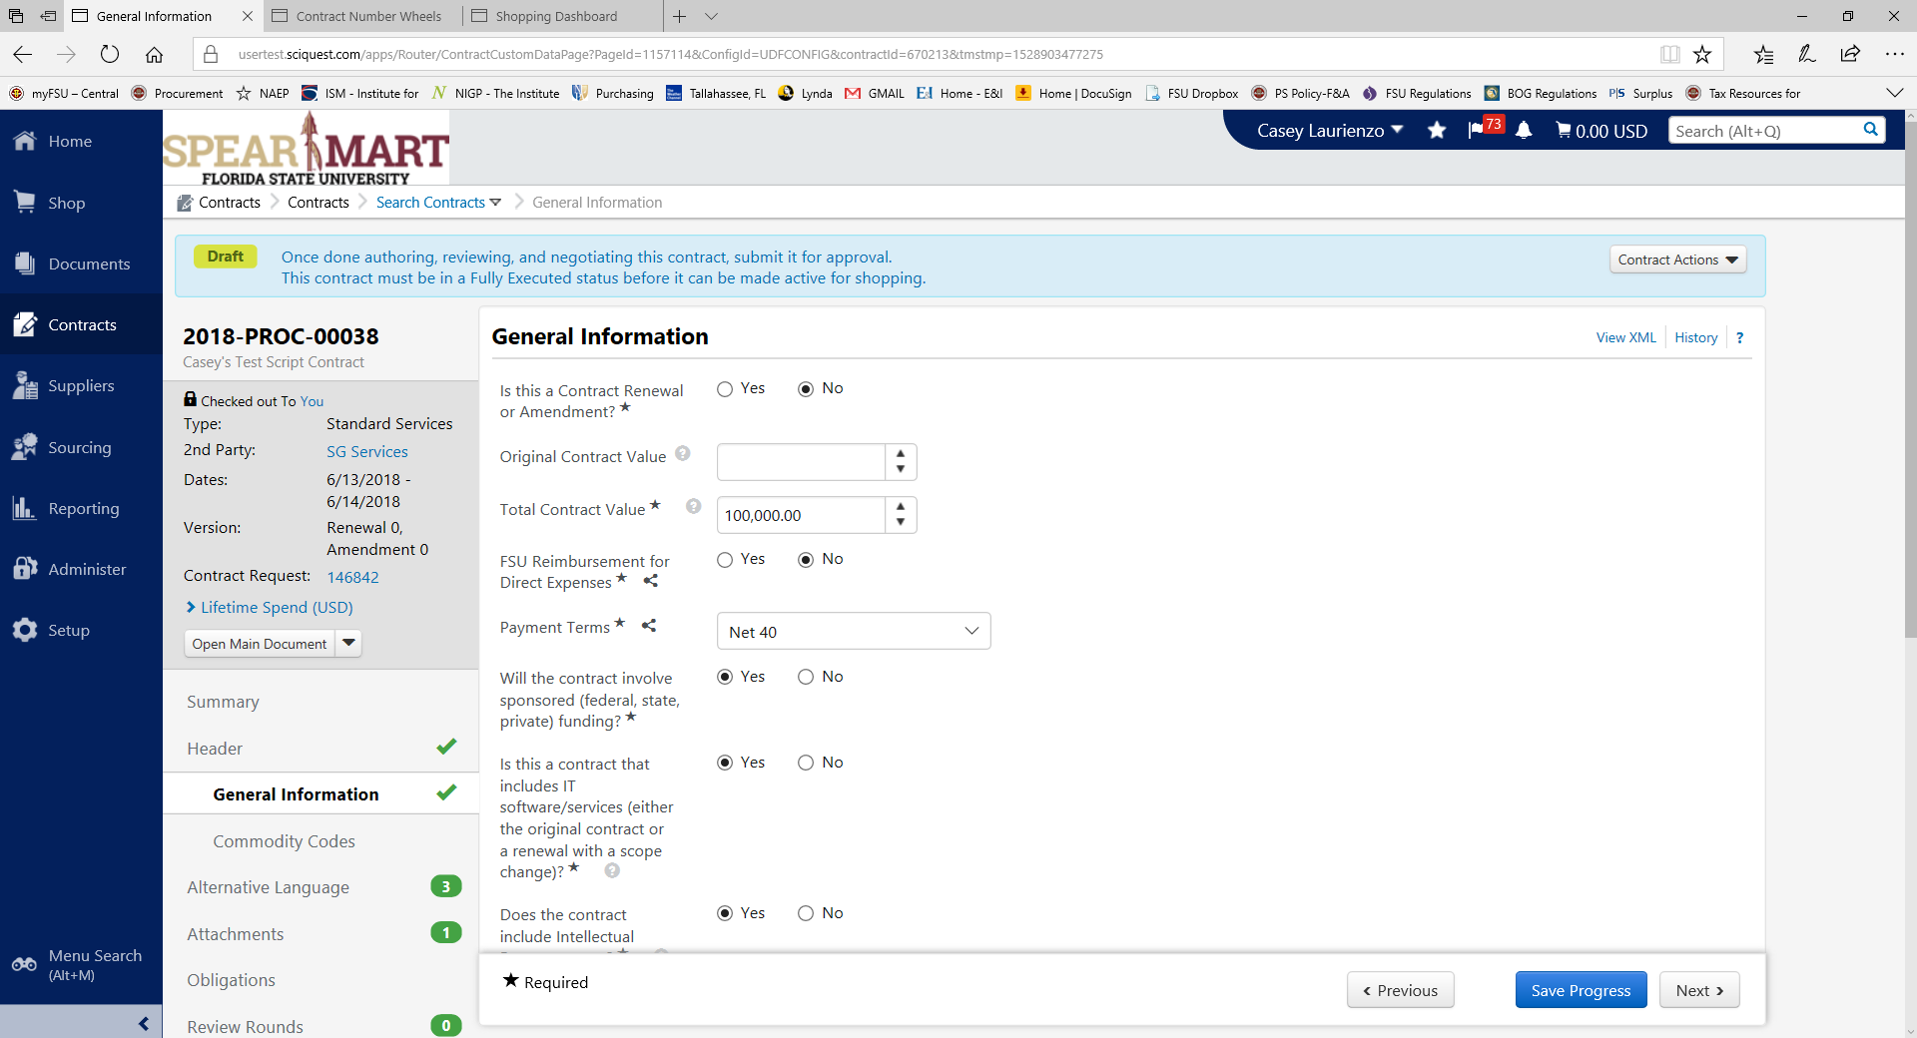

- Commodity Codes: Optional, your decision to use or not. Once completed select “Save Progress” and “Next”.
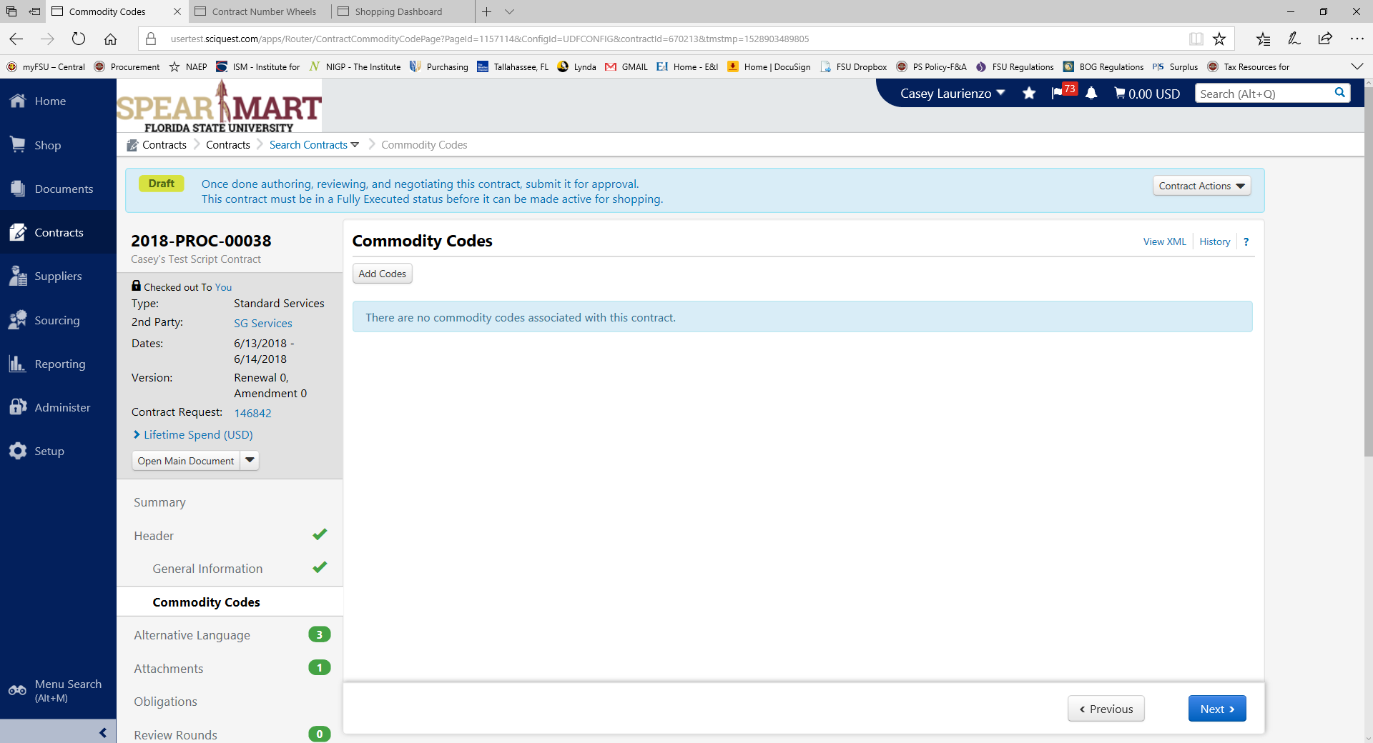

- Alternative Language: This section allows you to see what optional clauses were selected based on your questions in the General Information section and also what contract type you selected. You can also see fallback clauses for language that has optional language (ex: Indemnification). You can use default or fallback language. What you select here will populate in the template. Once completed select “Save Progress” and “Next”. This section will be blank if you aren’t using a template or if your template is not set up with a clause library.
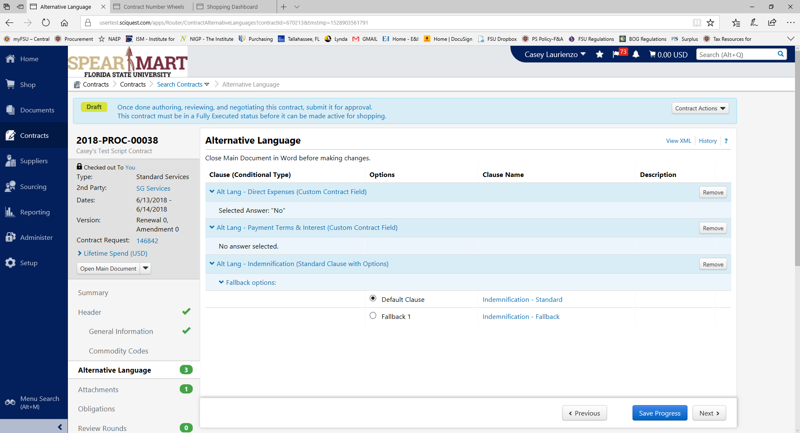

- Attachments: This is where you complete drafting of your contract. Go ahead and select the Main Document link. If you did NOT select a template when setting up the contract on the first few screens, in this section you will see an “Upload Main Document” option where you will upload the document for review. You can skip to the next screen.

- Once you’ve pulled up the Word document, and allowed for editing, you will see the Jaggaer Contract Authoring for Word tool pop up to the right. Here it will ask for your App Activation Code or an Authorization Key. You will need to request a code from the Contract Administrator at contracts@fsu.edu. Enter the code and once validated you should see the below screen.
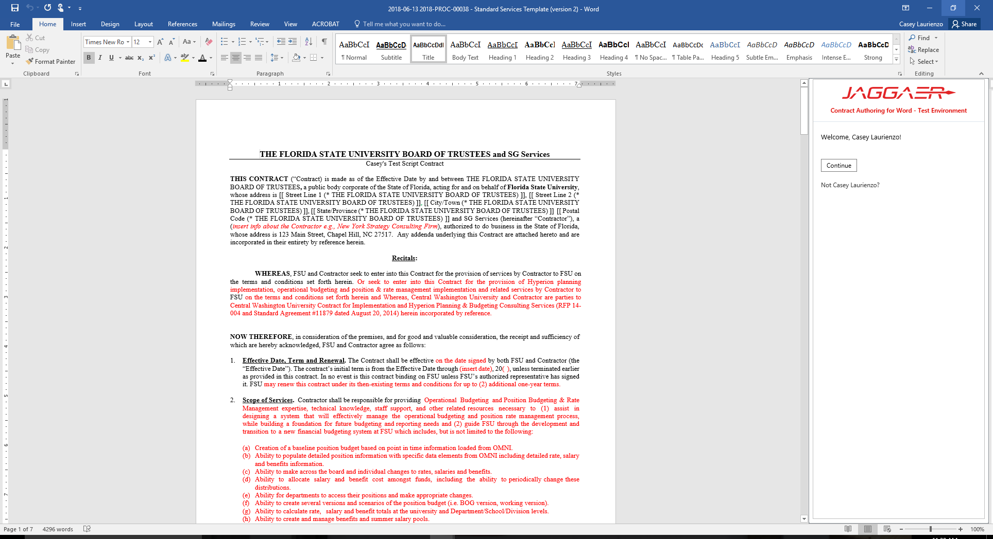

- Once you’ve been authenticated into Word/Jaggaer authoring, you will be ready for editing. You will see areas where auto population occurs, this means that a placeholder or tag has already been tied to the template, so that does not need editing. In this example, only the areas in red need to be reviewed/edited but your template may look different depending on your contract type. Go ahead and make any changes.

- If you would like to add MORE placeholders, then you may do so using the options in the word app to the right. Simply insert where applicable.

- Once you’ve completed any editing, you’ll need to select the ‘Check In” button on the bottom of the side panel. This will let the system know you have a draft ready. If you don’t want to save your changes, then select ‘Discard Check Out’. Also, you will need to describe what changes you made or general comments before selecting OK.

- Close out of the document and only Save a Copy if you want a version on your hard drive. Remember that you will be doing all reviews and execution activities within the system so a copy should not be necessary.

- Once you’ve completed authoring, you will see that the changes are effective on the Attachments tab. Also keep in mind that the system tracks versions, so you will have prior versions for reference.

- Now, you can move to the Obligations tab. The Obligations area is a custom area where Contract Managers can create items to assist with Contract Monitoring. This section is blank now but can be modified after the contract is approved and executed.

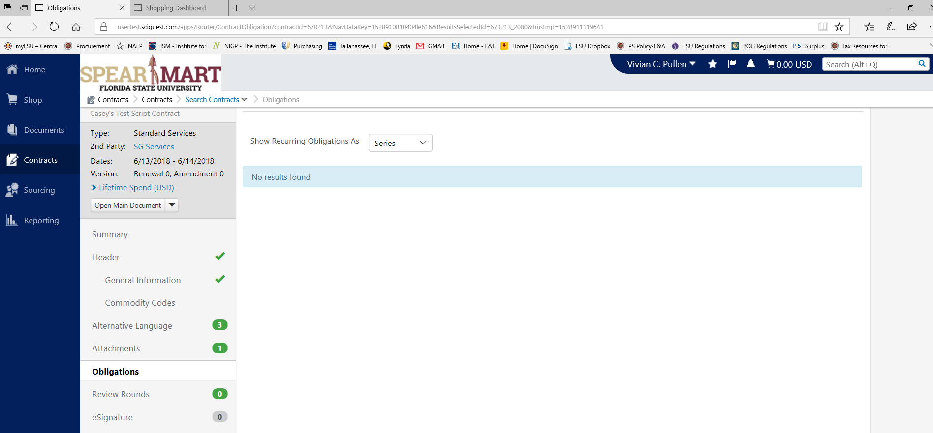

- Next, move to Review Rounds. This area is where the Contract Manager, or author, is going to send the Draft document for review internally OR externally BEFORE it is sent through the official and final approvals and signatures.
- Internal Review: Internal Review should be other reviewers within the FSU community that also have access to the module. If someone needs to review that is an FSU employee but does NOT have access to the module, you can use the External Review option.
- External Review: These reviews are for those reviewers that need to review a draft that either do not work for FSU or do not have access to the module.

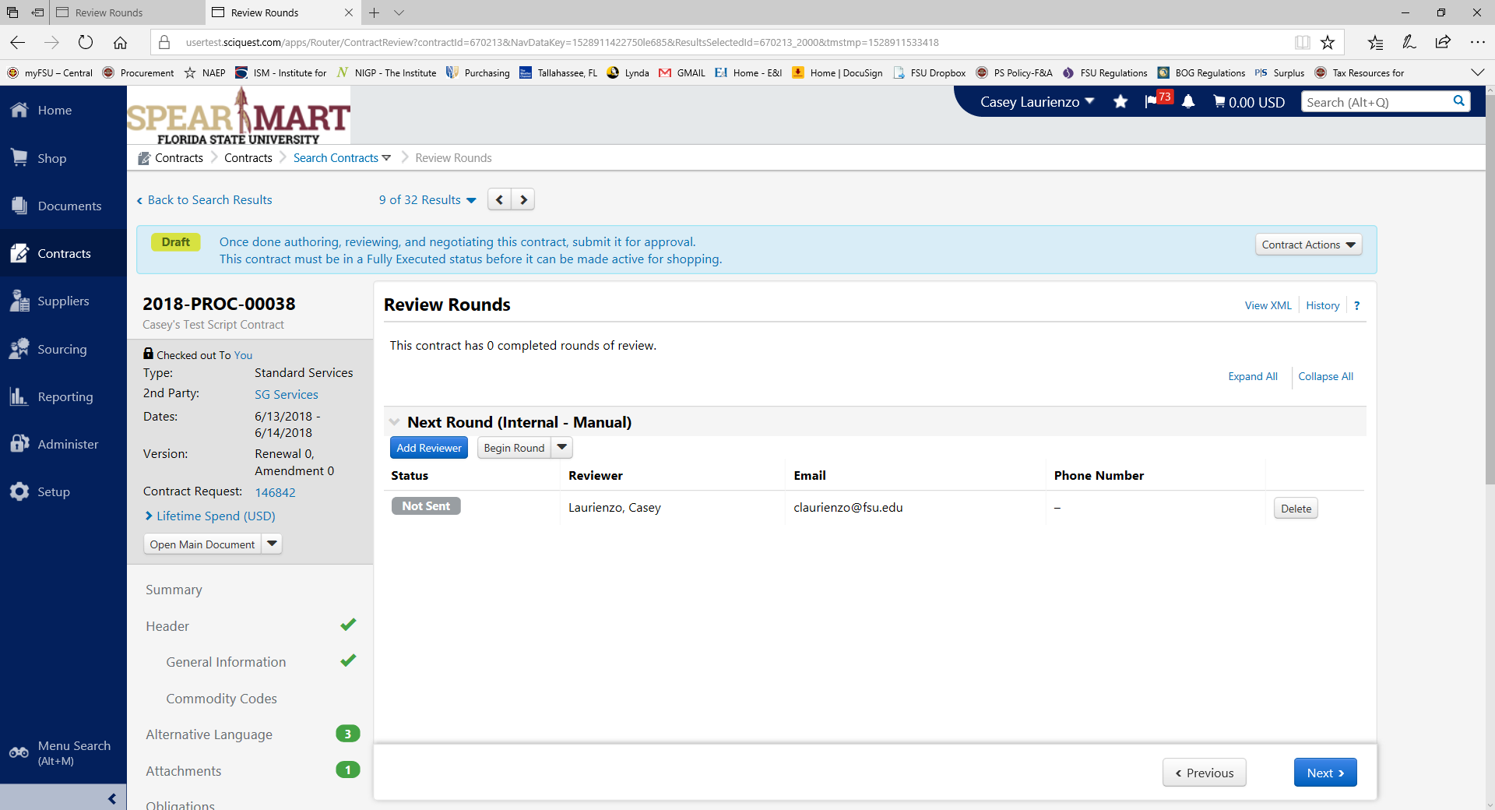

- To begin a draft review, select “Crate Manual Internal Round” or “Start External Round” and enter applicable information. The other party will receive an email that asks them to review the document. Once they’ve completed their review you will receive a notification in SpearMart and any changes/comments can be reviewed.
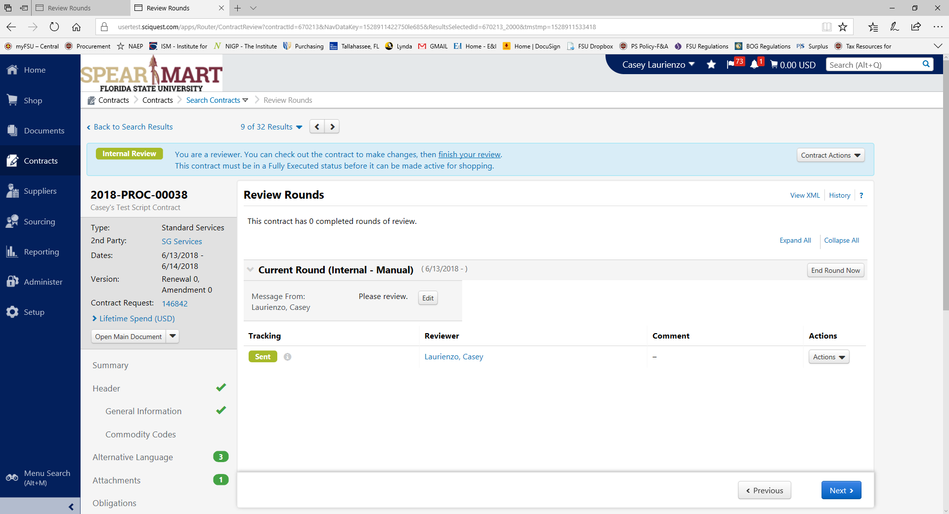

Email notification:

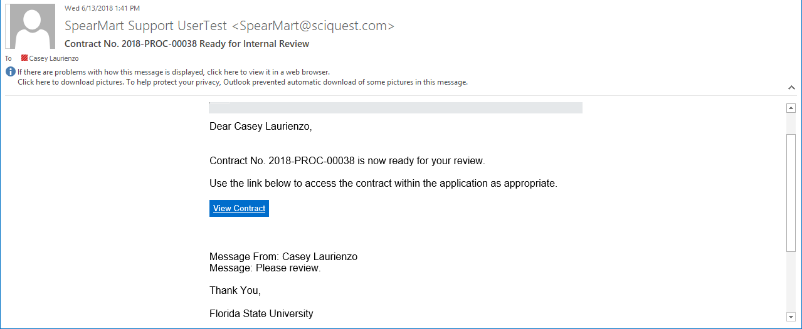

- When your review rounds are completed, it’s time to set up eSignatures, or you can skip this step if you aren’t obtaining eSignatures. Move to the eSignatures tab and at the top right of the screen, select ‘Contract Actions’ and make sure you have the document checked out by selecting ‘Check Out’.
- Add a signer: Select which signatory, select the Contact, and ‘Manually Enter Signer’ for both parties unless the names and emails are already correct.

- Next, YOU’RE DONE! You can move to the ‘Submit for Approval’ tab. You’ll want to make sure all areas are checked green, which means you’ve completed all of your required information. Also, note that you can select ‘View Approval Steps’ and see where your contract will be routed and to whom. You can follow along to see where it is at any given time.
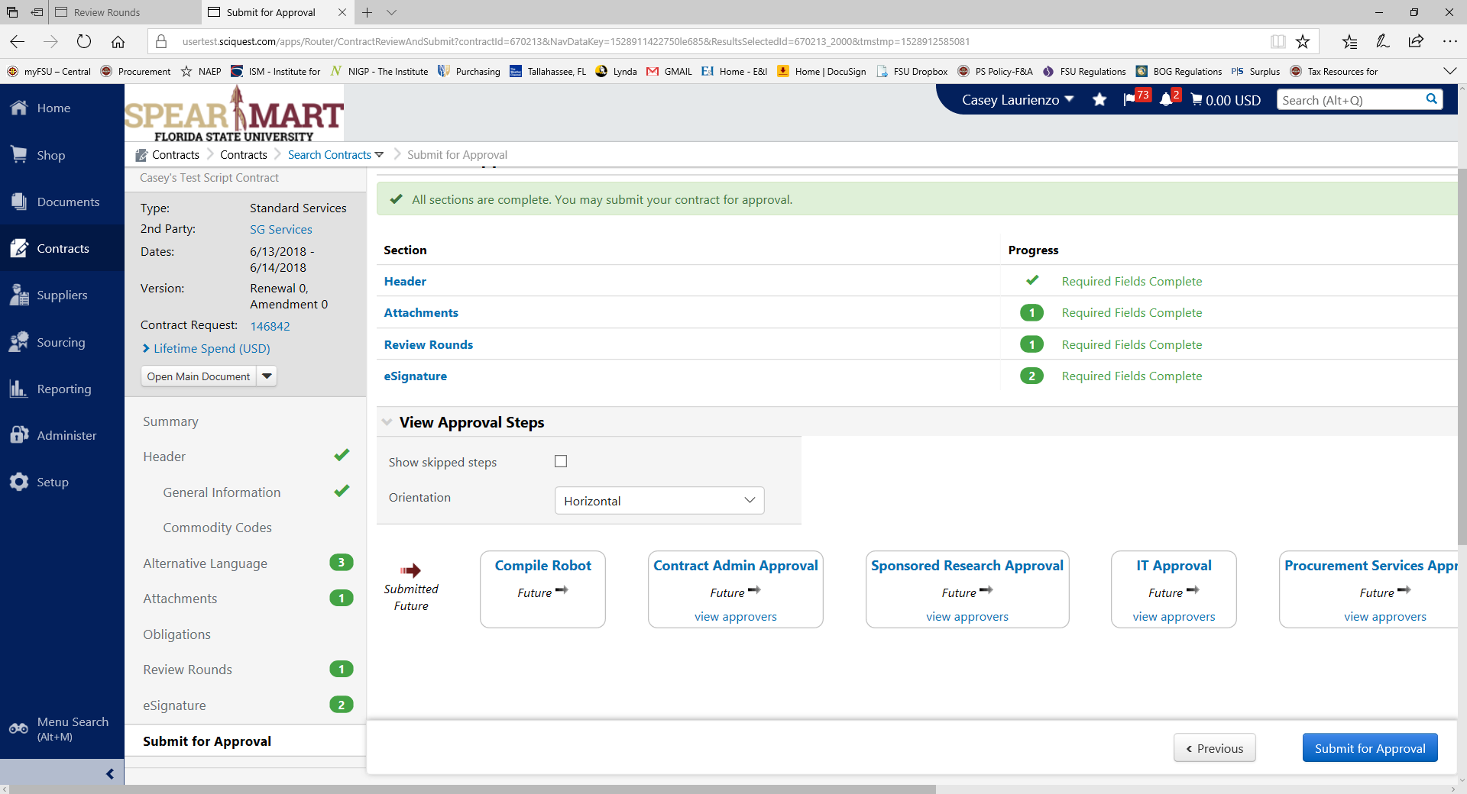

Now, ‘Submit for Approval’!

- Once all approvals have been obtained, and if you are obtaining eSignatures, you will receive a notification that the contract is ready to launch eSignatures. If not, you will receive a notification that all approvals are obtained and until a final document is uploaded, the contract will remain in Draft stage.

- To send for eSignatures, under “Contract Actions”, select “Launch eSignature”. The system will take you to DocuSign to ensure that signature tags are correct. You may need to edit or add tags, or depending on your contract type they may already be set up.

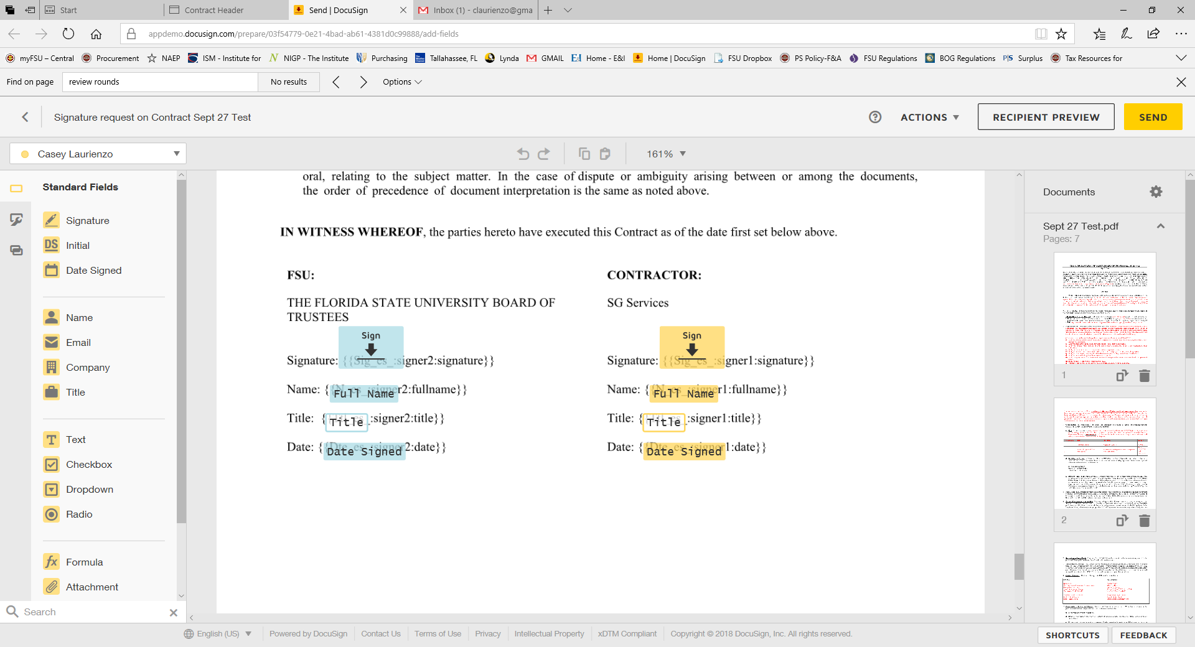

- Once ready, select Send and then the document will route for eSignature. You will receive emails/notifications when signatures are obtained and finally when the document is “done”.

- When the contract is “completed”, the status bar at the top of the contract page will show “Completed”. It will show “Draft” still if not completed and of course “Expired” for contracts that have expired:

Congratulations! You now have an executed contract and can now begin post-execution activities.

Section C: Contract Obligations

- If you are the Contract Manager, and once your contract is completed, move into the Obligations tab and begin creating any obligations (deliverables or other required tasks). This section is NOT required but highly recommended as you are able to set notifications for reviews, project milestones, etc.

- Another optional feature is to create an Obligation Library, for Obligations you think you may use frequently. Select ‘Contracts’ from the left side panel>Contracts>Libraries>Obligation Library

From here you can ‘Add Obligation’:

Fill out as desired:
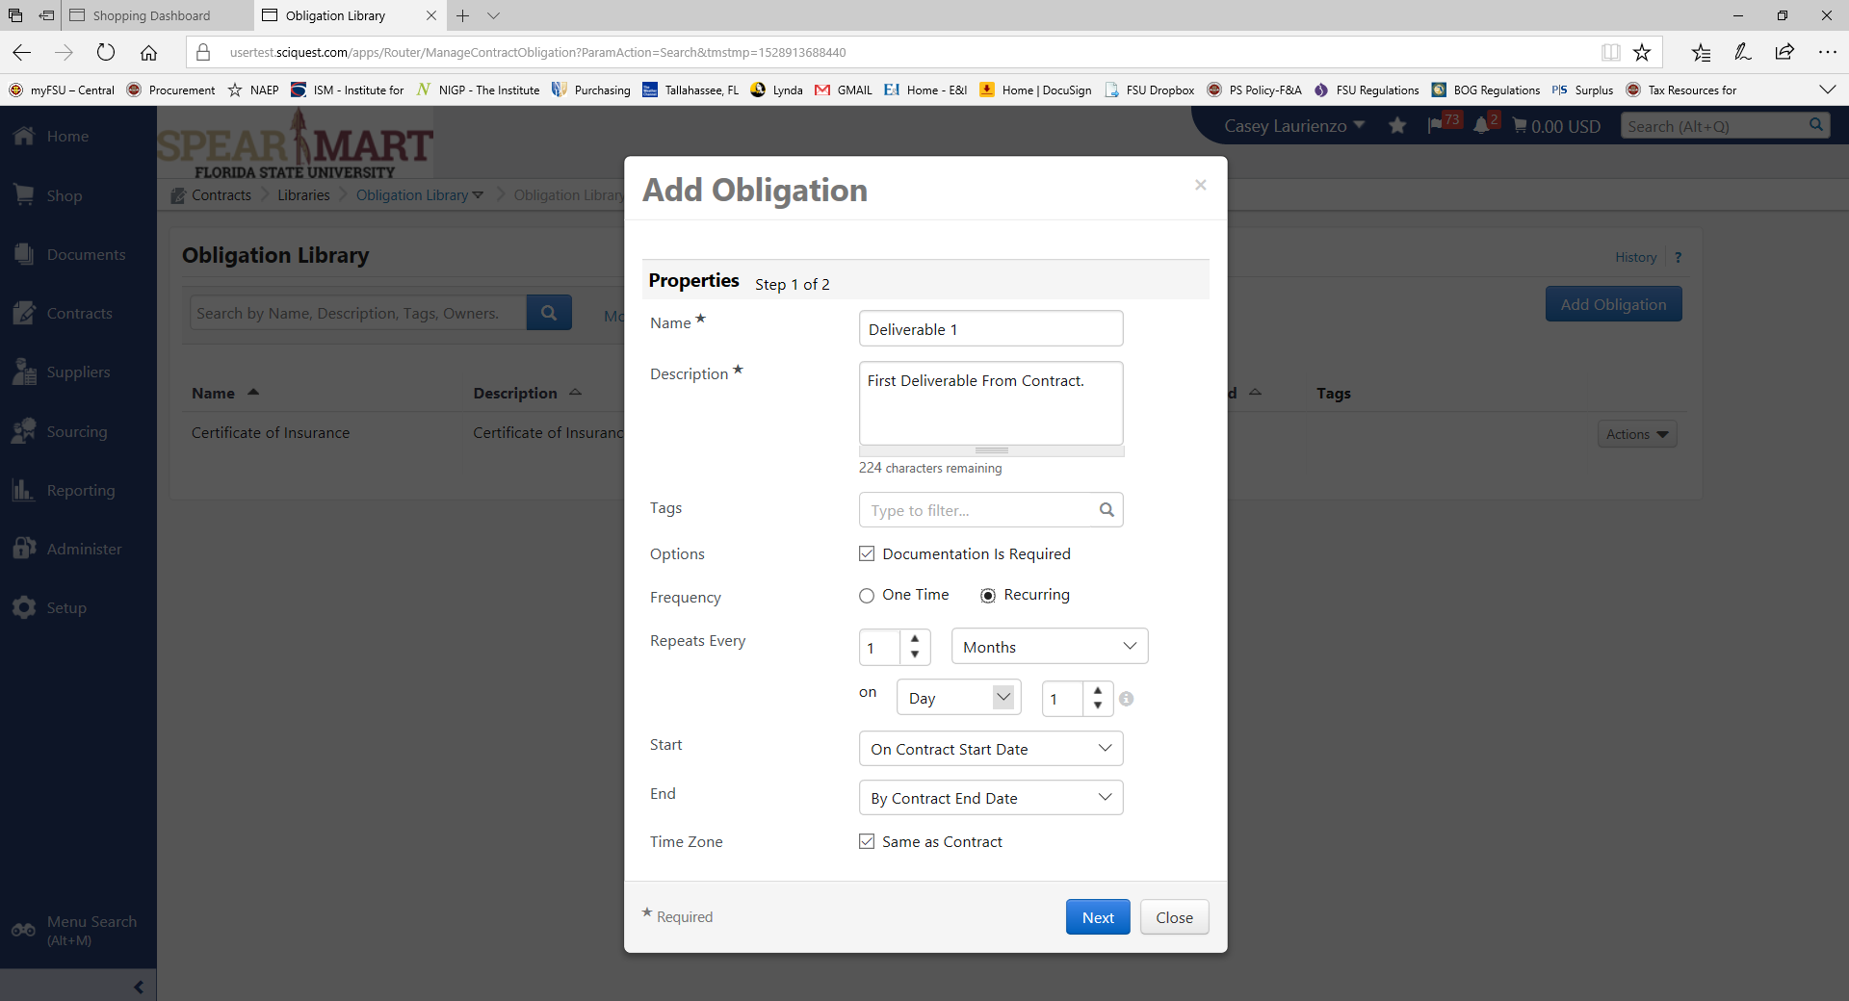
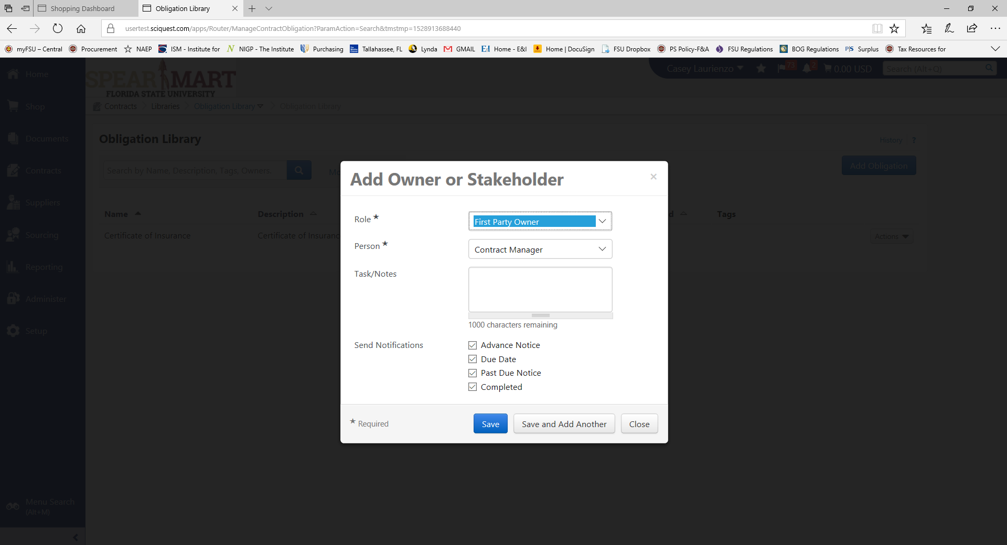
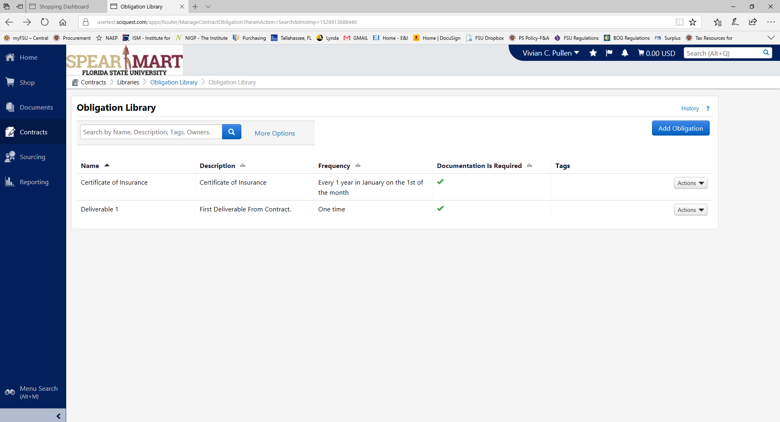
These obligations can be added to contracts after completion. After creating an Obligation, go back to your contract and add it on! You don’t HAVE to use the Library, but remember that if you are managing a large number of contracts with similar attributes, this could be a time saver.

Section D: Renewals and Amendments

- When it’s time to renew your contracts, or amend, you must first upload the unsigned draft document and then you can renew or amend.
- From the Contract Actions tab, select “Check Out for Internal Edit” and then you will be able to edit the contract.
- From the Attachments tab on the left of the contract, select “Actions” next to the Main Document and “Unassign as Main Document”. This will allow you to add a new main document for routing a renewal or amendment.

- Once unassigned, you will see a new option appear next to Add Attachments called “Upload Main Document”. Select this option and then either select a template or upload your draft renewal or amendment. Then, check back in the contract from the Contract Actions tab.
- Once a new document has been uploaded, you can move on to renewing or amending the contract.
- Select “Renew” or “Amend” from the Contract Actions tab (Contract Manager).

- From there you will certify renewal or amendment and select “Yes”:
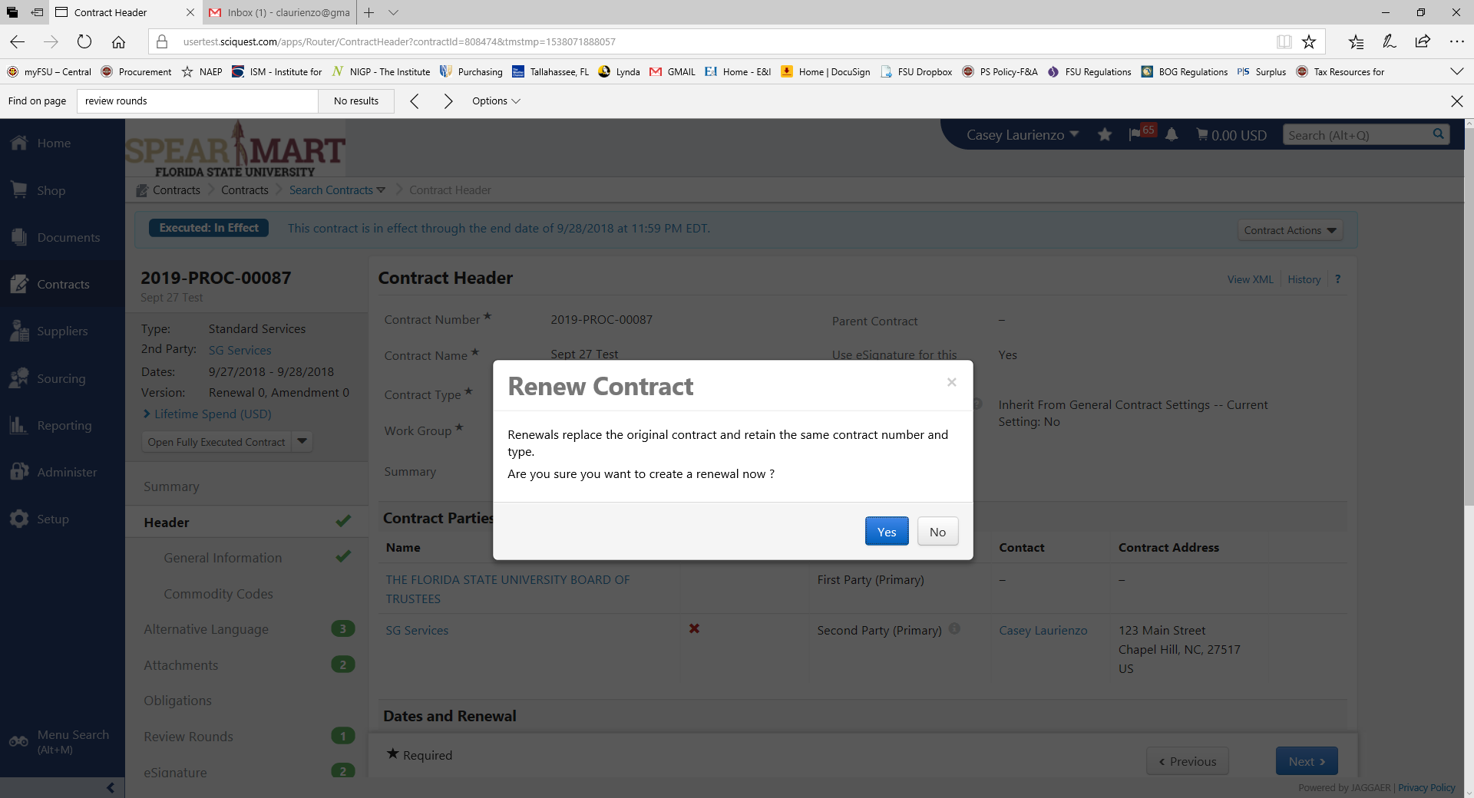
- From the next screen you will follow the same steps as an original contract, starting with editing the start/end date fields to match the new dates, if applicable, or any other fields that may have changed. The document will route for approval and signature just as the original document did.
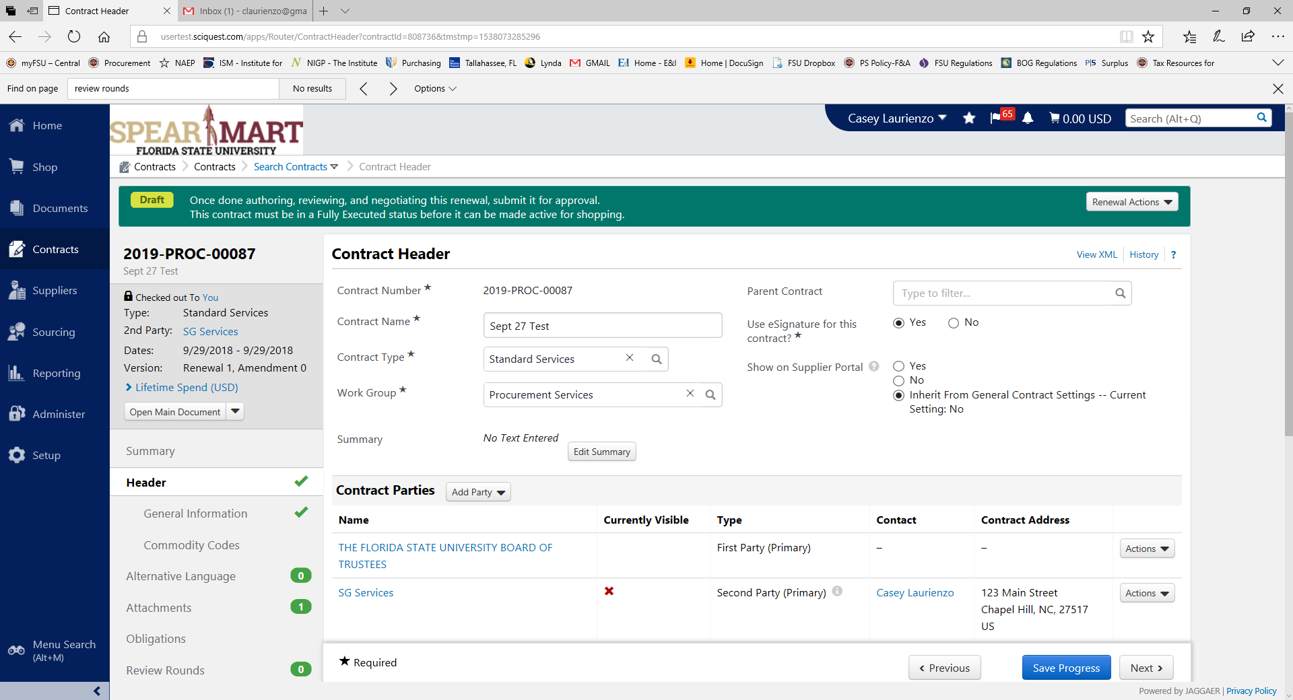
- Remember that when you move through the tabs, to update any new info including original and total contract value.
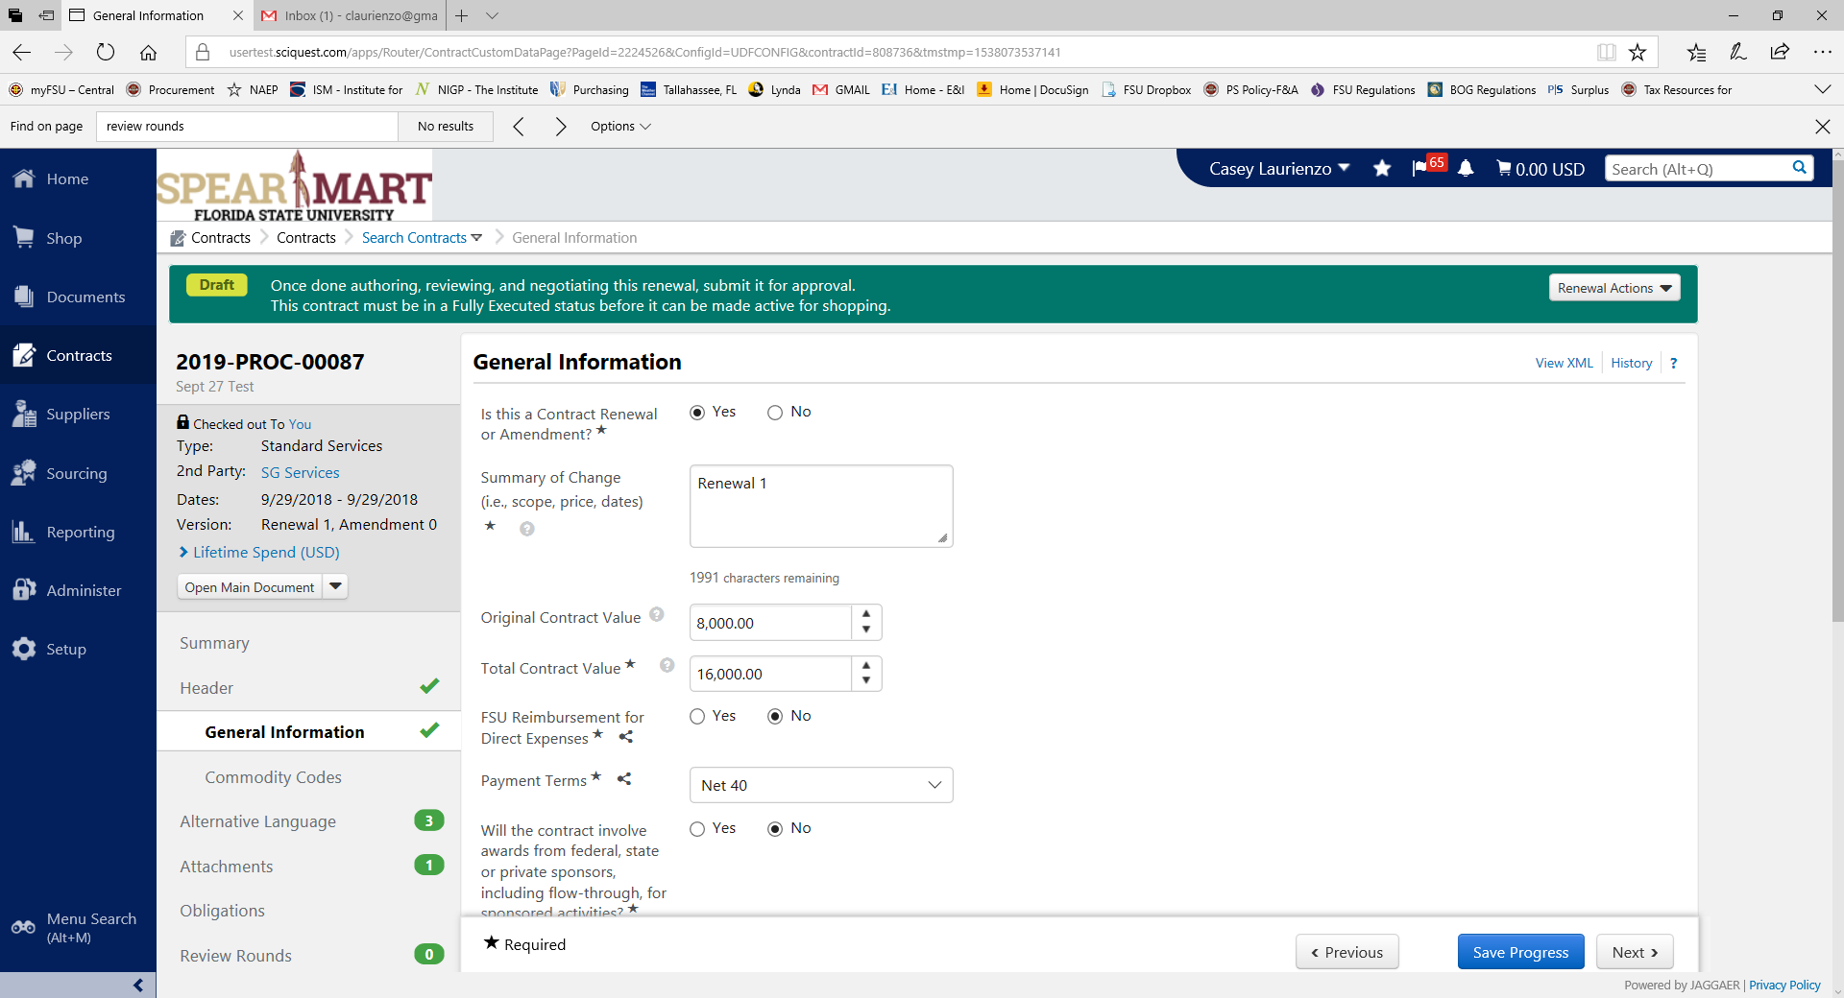
- When you get to Attachments, you will see the new document that you loaded as the Main Documents, from there you will want to edit it and finalize your draft. You can perform internal and external review rounds as you would with an original and all remaining steps will mimic the “create contract” steps. Once you’re ready, you will send for approvals and signature as you would any other agreement. Once it’s fully approved and signed, the contract will be considered executed but also in either renewal or amended status. For searching contracts, you will be able to search by either renewal, amended or original contract status.
- It is a good idea, once you’ve started to add attachments or amend or renew during the life of the agreement, to make sure you’re naming the attachments appropriately. The most active document should be the Main Document always. The original can be renamed Original Contract once the first renewal is executed, for example, just so that it’s less confusing.

Section E: Approving Contracts

If you are an Approver, follow these steps to approve or deny a contract.
- Notifications for approvals will be sent to your email as well as through a notification in SpearMart. Should you choose to approve straight from the email, simply open the link, review the document and approve or return. Directly from the email pop-up.

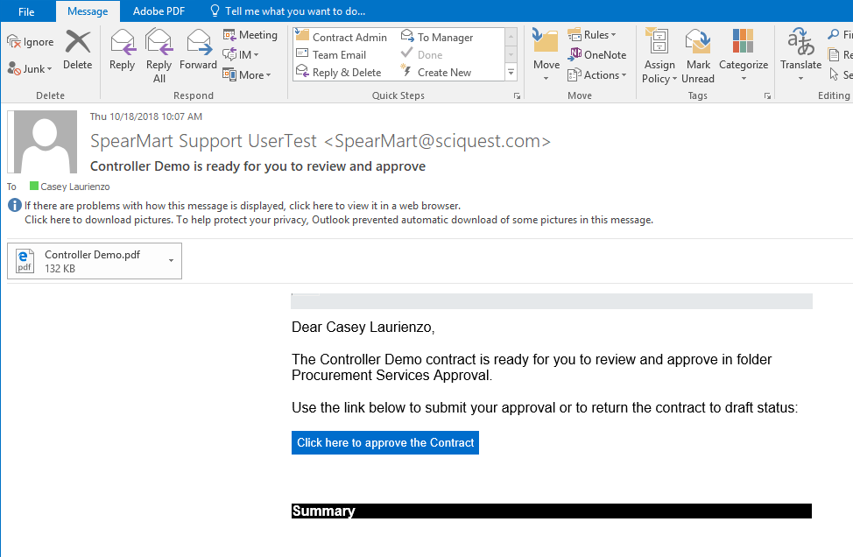

- If you approve from inside the module, click on the links and “Go To Contract”.
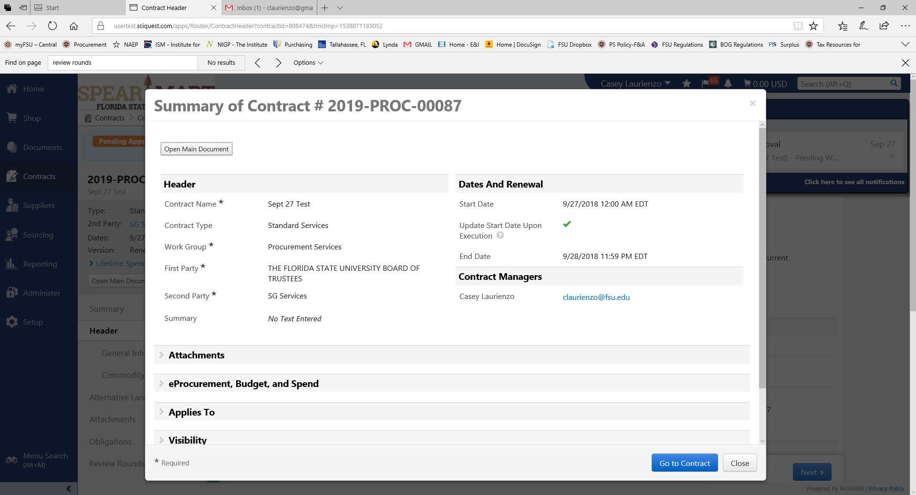

- You will be directed to the contract page where you will be able to review all information, including the document. Review the info/document and when ready to take an action, select the “Contract Actions” button on the top right of the screen.
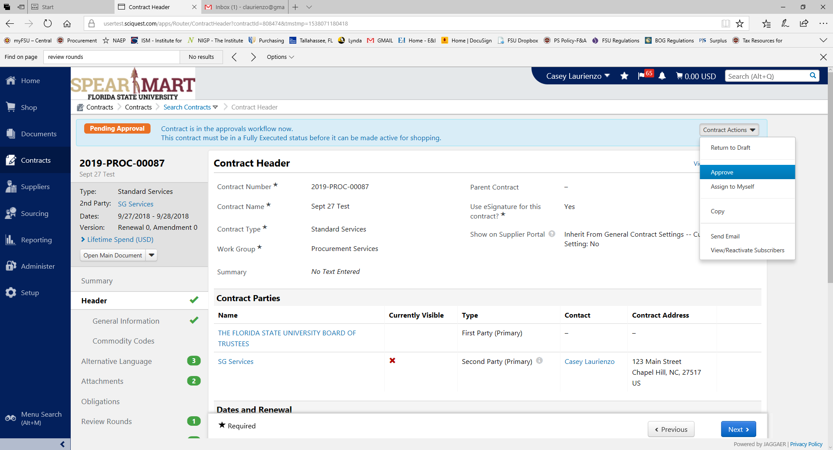
- Select either “Approve” or “Return to Draft”. “Return to Draft” will notify the author that you have NOT approved and offered comments or feedback. The Contract Manager will have to start the approval routing process over if an item is returned, just like a Requisition. Either way, once you’ve taken an action, you are done!

Section F: Reports

- Reports are located on the main Contracts selection pane. The reports are canned reports but can be customized to a date range or other filter criteria. Reports can be downloaded to Excel as well.
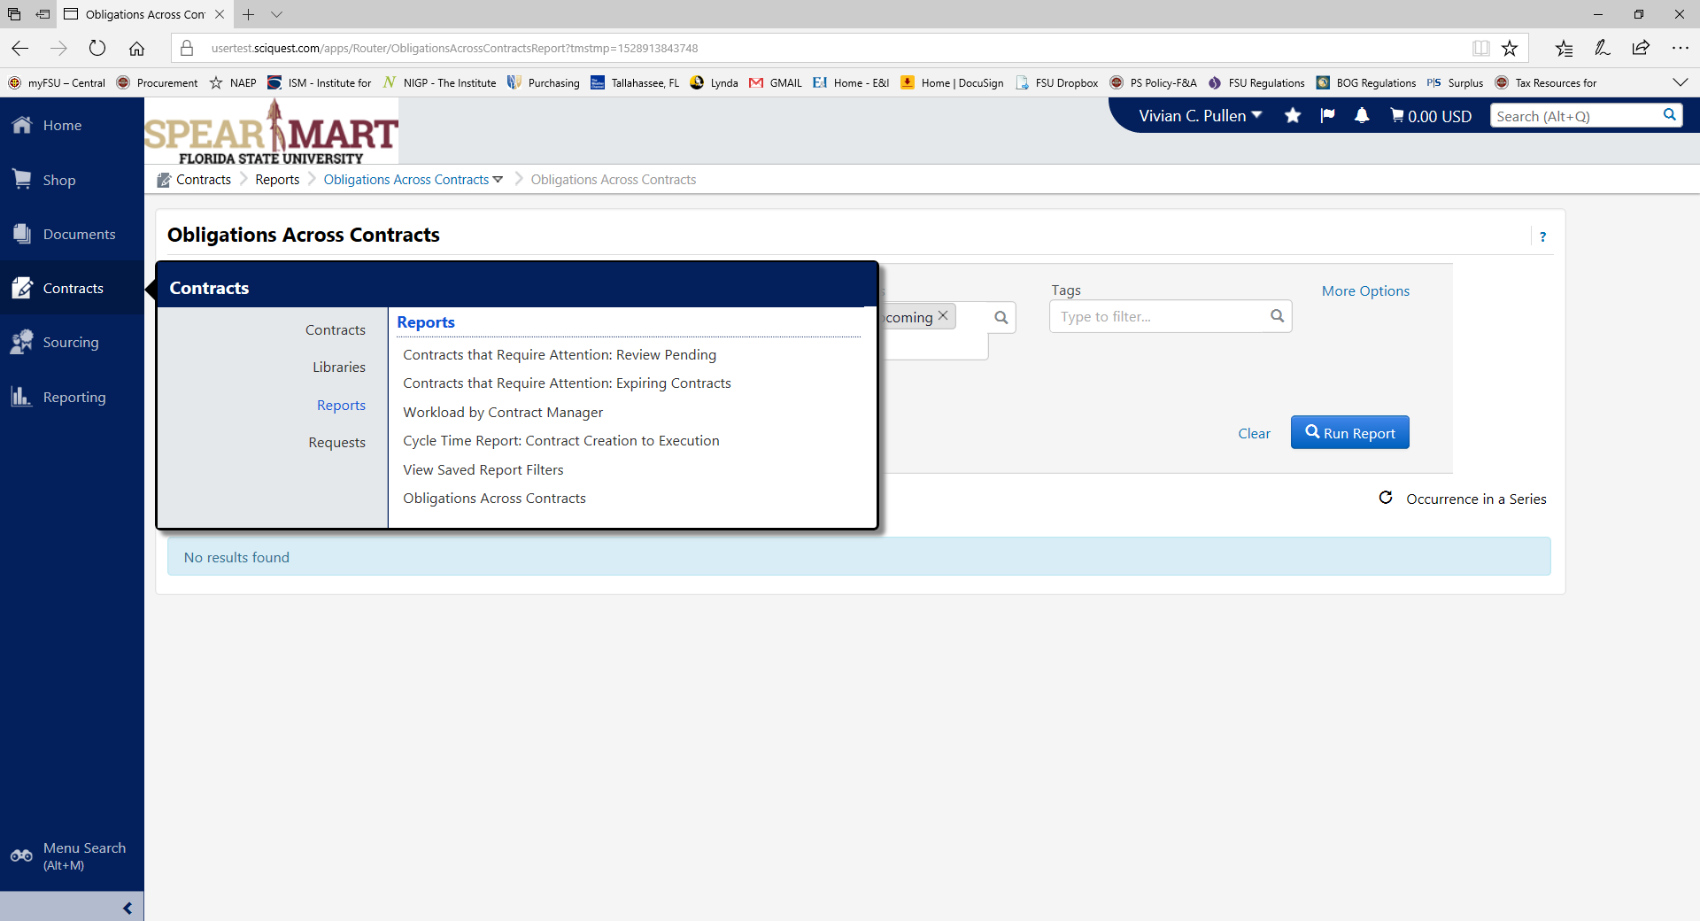

Section G: Contract Search

- Searching contracts can be done from main Contracts selection pane or the Contracts Home page. Contracts can be located by a variety of fields and can be exported to Excel. The Advanced Search fields create more search criteria.
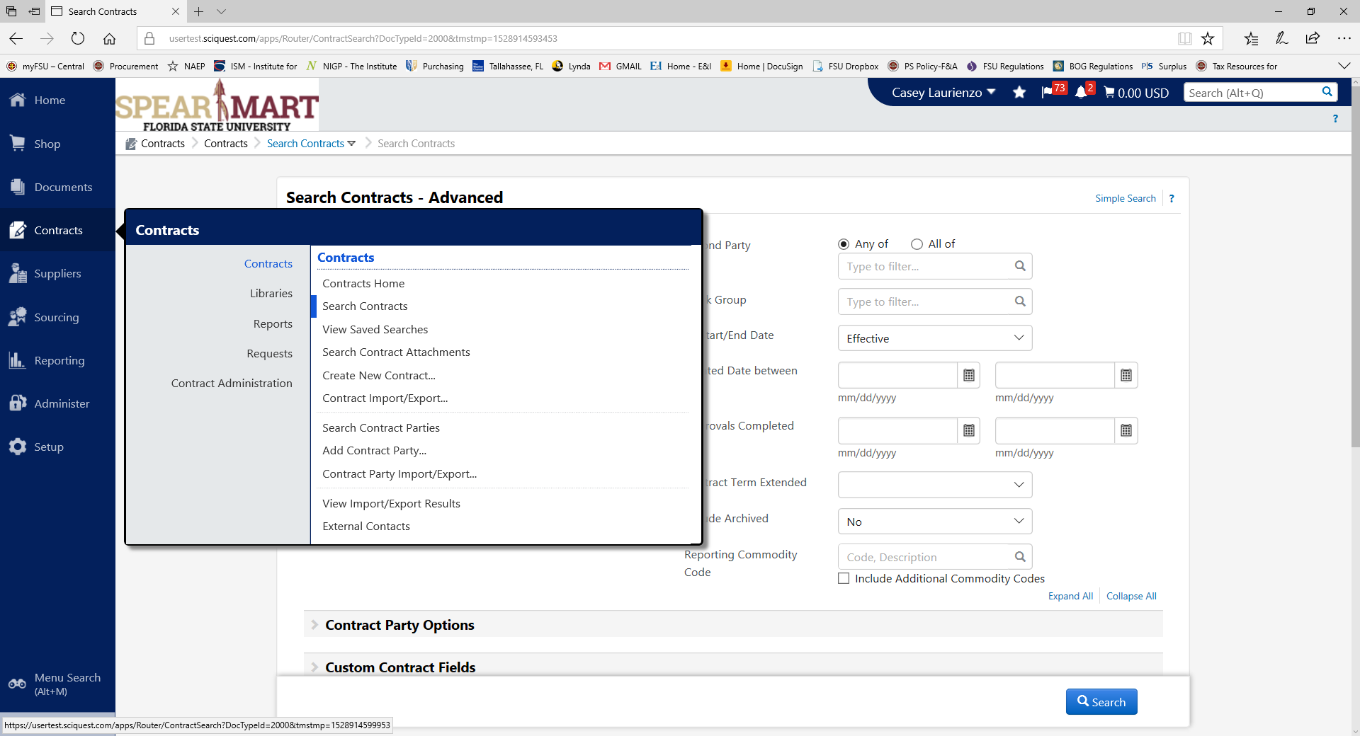
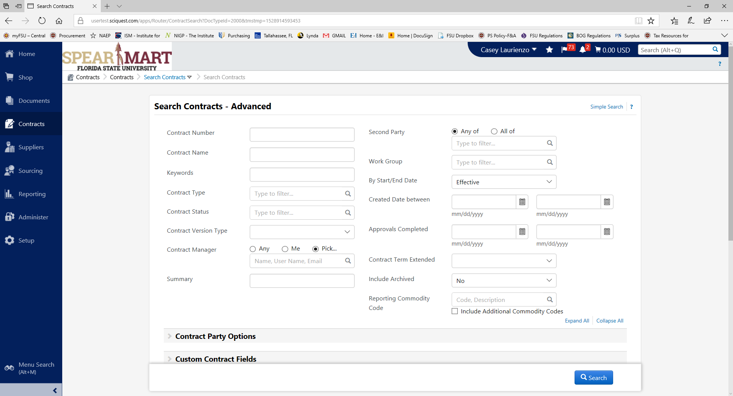

Once you’ve done a search, you are able to export your searches into an Excel spreadsheet. Use this feature for most of your reporting.
Appendix A-Contract Types

The following are the definitions of the various contract types. This list will assist users in understanding what kind of contract to use.

Contract Groups | Contract Types | Definition
Expenditure | Goods and Services | Purchases of Goods and Services might include the procurement of general services, goods and products, professional & artistic services, or software licenses, as examples.
 | -Goods | Consumables or tangible items being purchased.
 | -Services | Intangible items, often deliverable and performance based payments.
 | -Professional and Artistic Services | Second party is offering a specific
 | -Consulting | Any arrangement where a consultant is being used for University business.
 | -Charters (Air and Bus)
 | -Equipment Leases/Maintenance
 | -Honoraria | Honoraria are tokens of gratitude or appreciation. It is a one-time payment made to an individual, who is not an employee of the University.
 | -Hotels
 | -Standard Services | To be used for any other service not listed.
 | -Software Licensing & Services
 | -Professional & Artistic Services | Agreements used when a non-University employee will provide a specific service, or services, and will receive payment for their work.
 | Real Property | Agreements pertaining to the purchase, leasing or management of real property.
 | -Land Acquisition | Agreements for the purchase or sale of real property.
 | -Leases | Agreements for rental of property, whether landlord or tenant relationship.
 | -Management | Agreements for the management of real property.
 | Construction | Construction Contracts are typically initiated by Facilities and include architectural, engineering and land surveying services.
 | Legal Services | Services obtained by the Office of General Counsel to assist with Legal matters.
Revenue Generating | Concessions | Concessions grant access to University property, whether tangible or intangible, in exchange for payment.
 | -Sponsorships | An individual or organization providing sponsorship or support to the University.
 | -Managed Services | Services provided on behalf of FSU, usually for FSU property or businesses.
Non-Monetary | Affiliation Agreements | These types of agreements provide a benefit to our students in terms of experience and additional learning opportunities; provide benefit to the second party receiving services of FSU students.
 | Intellectual Property | Intellectual Property Agreements pertain to a third party’s use of our intellectual property, or vice versa.
 | -Copyright | Pertain to the use of one parties copyright material, whether FSU or a second party.
 | -Data Use/Sharing | Specifically deal with the transfer of information from two parties.
 | -Material Transfer | Material Transfer Agreements govern the transfer of tangible research materials between the University and another company or institution.
 | -Inter-Institution | Agreements between similar institutions for the purpose of sharing or marketing intellectual property.
 | -Non-Disclosure/Confidentiality | Non-Disclosure Agreements (NDA’s), or confidentiality agreements, outline confidential material, knowledge, or information that two parties wish to share in order to conduct business with one another.
 | -Patents and Trademarks | Agreements whereby the University is going to pay a third party for  patent or trademark use, or vice versa.
 | Inter (Intra)departmental Agreements/Service Level Agreements | Agreements between FSU Departments, Offices, and/or Colleges.

