OMNI P-Card Recon Form Instructions

Each month, a reconciliation form will be completed by the either Proxy, the Cardholder, or the DDDH(or Authorized Signer).

- - Sign into OMNI and click the OMNI Financials Link

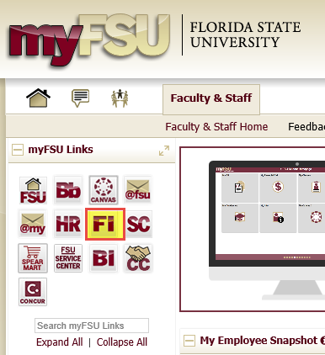

- Navigate to the form. When available in OMNI FI, the navigation will be: Main Menu> Purchasing> Procurement Cards> PCard Reconciliation Form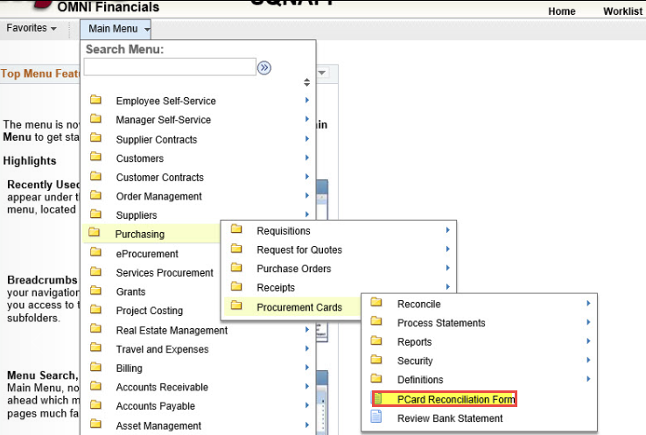

- This will lead to the “Search/Fill a Form page”
To complete a new Reconciliation Form, Click the “Add a New Value” tab.
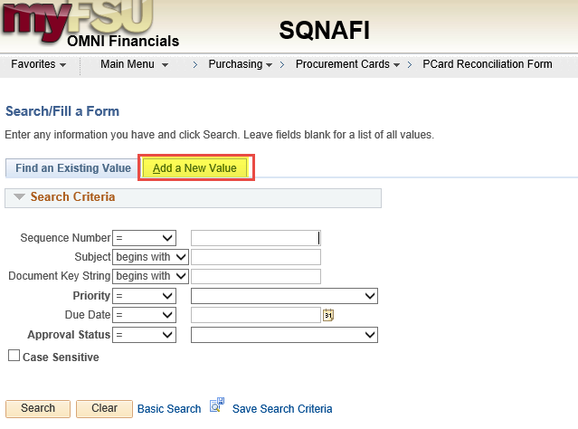

- The P-Card Reconciliation Form has 3 tabs: Form, Instructions, and Attachments.
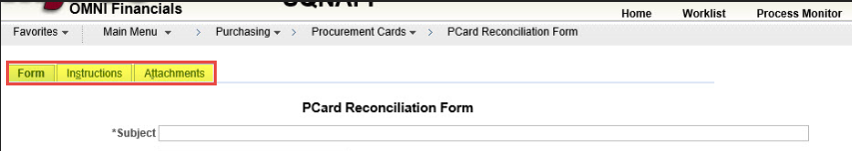

- The Instructions tab has a quick walkthrough of using the P-Card Recon Query (FSU_CTRL_AP_PCARD_RECON) to look at receipts and filling out the Reconciliation Form.

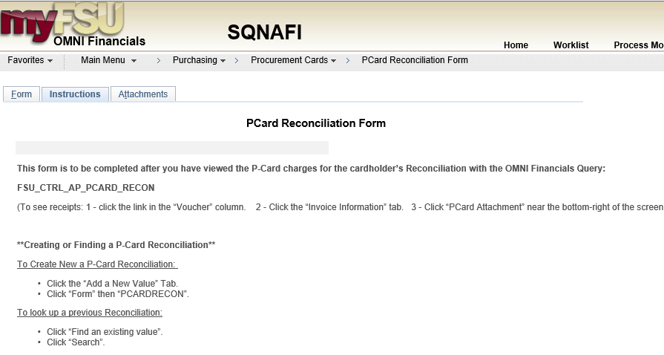
- The Attachments tab is where you will attach a copy of the Excel file generated with the P-Card Recon Query. This will have the Cardholder’s charges and links to their vouchers where each receipt is located.
The user must also attach a signed and completed copy of the paper P-Card Reconciliation form.
IF THERE ARE NO CHARGES, NO ATTACHMENTS ARE REQUIRED.
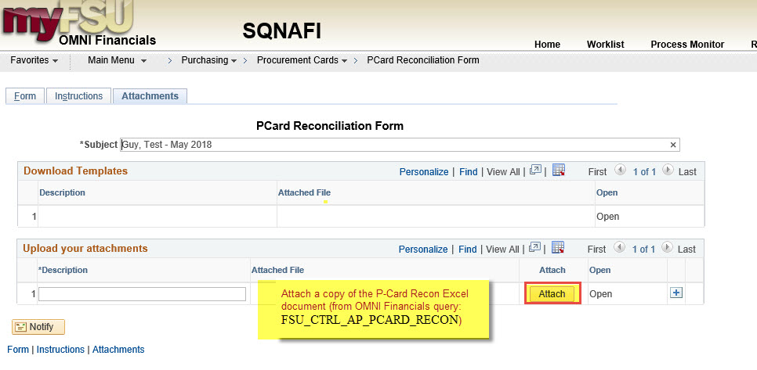

- The Form tab is where you will enter the information for the monthly P-Card Reconciliation.

- Subject: enter the Cardholder’s name, the month and year of the Recon (This is what you will see if you search through your own Recon forms later)

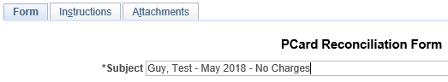

- Priority and Due Date: PLEASE DON’T TOUCH THESE.

- PCard Role: Select your role in the P-Card process from the drop-down menu.

- Cardholder Name: Lastname, Firstname

- Cardholder EmplID: 9-digit FSU Employee ID# (use the Magnifying Glass icon to search)
- Home Department: Cardholder’s 6-digit FSU Department #

- Fiscal Year: Select from the drop-down menu.

- Month: Select from the drop-down menu.

- More Information- If there are no charges this month, please type “NO CHARGES” in the box.

When the fields are filled out, Click Save.

- Click Submit when ready to complete the form.
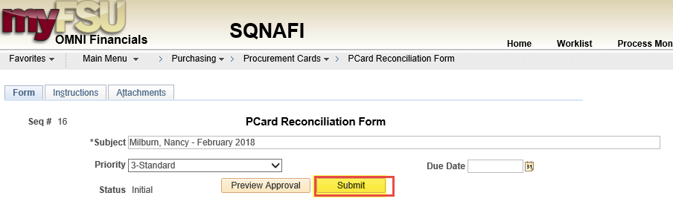

Searching for your completed Recons

1. Navigate to the form.
Main Menu> Purchasing> Procurement Cards> PCard Reconciliation Form

2. On the “Find an Existing Value” tab, click “Search”.

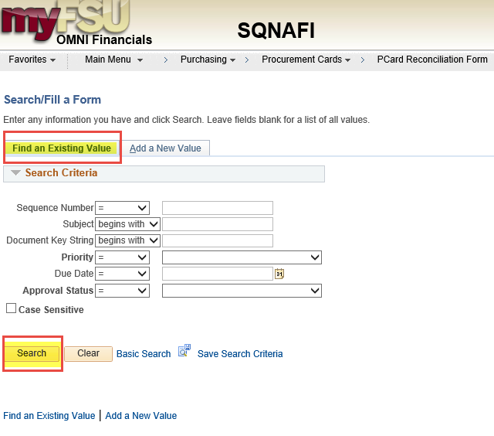

3. Click one of links below view a prior submission. 